ST. JOSEPH’S CATHEDRAL HIGH SCHOOL
COMPUTER SCIENCE 2
CANDIDATE NAMES:
- PROSPER LUKAMAJA MASUNGA
- COLLINS-PAUL PETER MSHALI
QUESTION 1:
- Source code
//
// Created by Prosper.dev and Collins.cpp on 10/08/2026.
//
#include <iostream>
#include <string>
#include <cstdlib>
#include <iomanip>
using namespace std;

class BankAccount {
private:
int accountNumber;
string ownerName;
double balance;

public:
// Create a constructor using initializer syntax
BankAccount(int accNum, string owner, double bal) :
accountNumber(accNum), ownerName(owner), balance(bal) {
cout << "Successfully created account for user " << ownerName << "!\n" << endl;
}

void deposit(double amount) {
if (amount > 0) {
balance += amount; // test using "bal" later
cout << "Successfully deposited " << amount << " TZS into "
<< ownerName << "'s account!\n" << endl;
} else {
cout << "[ERROR] Deposit amount must be positive and greater than 0.\n" << endl;
}
}

void withdraw(double amount) {
if (amount > 0 && amount < balance) {
balance -= amount;
cout << "Successfully withdrawn " << amount << " TZS from "
<< ownerName << "'s account!\n" << endl;
} else {
if (amount < 0) {
cout << "[ERROR] Withdraw amount must be positive!\n" << endl;
return;
}
cout << "[ERROR] Insufficient funds!\n" << endl;
}
}

void displayBalance() {
cout << ownerName << "'s BANK ACCOUNT " << endl;
cout << "Current balance: " << balance << " TZS." << endl << endl;
}
};

int main()
{
// Declare necessary variables
string name;
int accNumber;
double initBalance;
int choice;

// Print a welcome message to the user, input necessary data
cout << "----- Welcome to the Bank Account management system! -----" << endl;
cout << "Enter account number: ";
cin >> accNumber;
cout << "Enter account owner name: ";
cin >> name;
cout << "Enter initial account balance: ";
cin >> initBalance;

// Create user account
BankAccount account1(accNumber, name, initBalance);

// Display menu until user exits
bool menu = true;

while (menu) {
cout << "\nChoose an action from below:\n"
<< "\n1. Deposit money into account\n2. Withdraw money from account"
<< "\n3. Display balance\n4. Exit" << endl << endl;
cout << "Your choice: ";
cin >> choice;

switch (choice) {
case 1: {
double depositAmount;
cout << "\nDEPOSIT MONEY ....." << endl;
cout << "Enter amount to deposit: ";
cin >> depositAmount;
account1.deposit(depositAmount);
break;
}
case 2: {
double withdrawAmount;
cout << "\nWITHDRAW MONEY ....." << endl;
cout << "Enter amount to withdraw: ";
cin >> withdrawAmount;
account1.withdraw(withdrawAmount);
break;
}
case 3: {
cout << "\nDISPLAY BALANCE ....." << endl;
account1.displayBalance();
break;
}
case 4: {
cout << "\nEXIT PROGRAM ....." << endl;
cout << "Goodbye!";
menu = false;
break;
}
default: {
cout << "\nInvalid choice!" << endl;
break;
}
}
}
}

- Test run of the above program
- First sample run
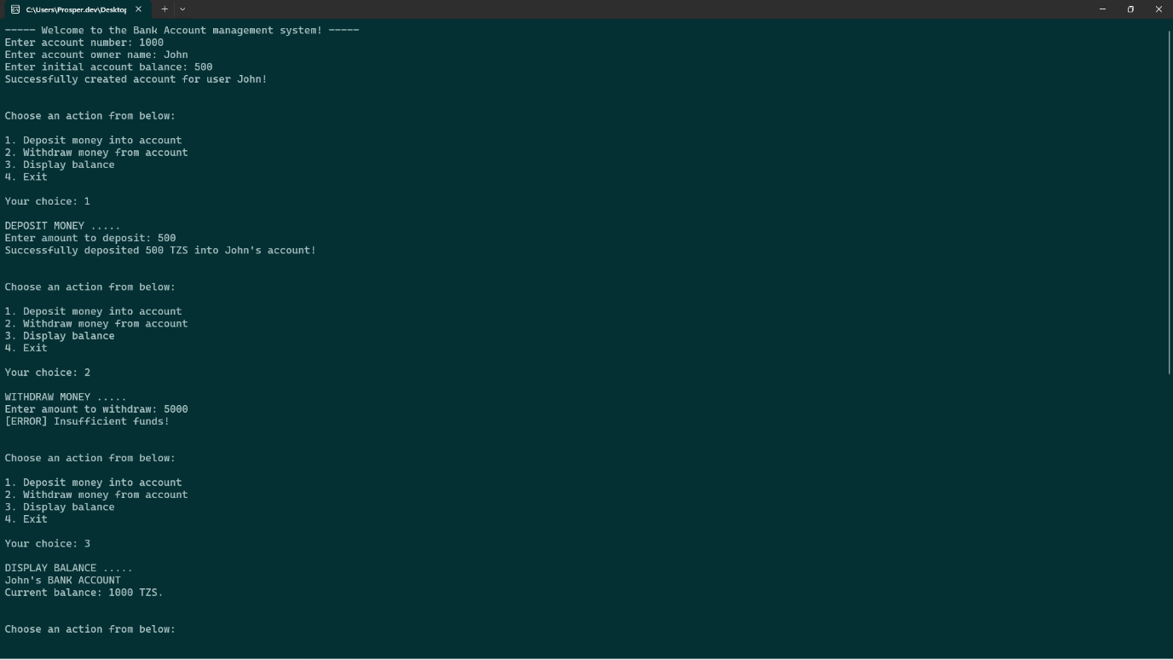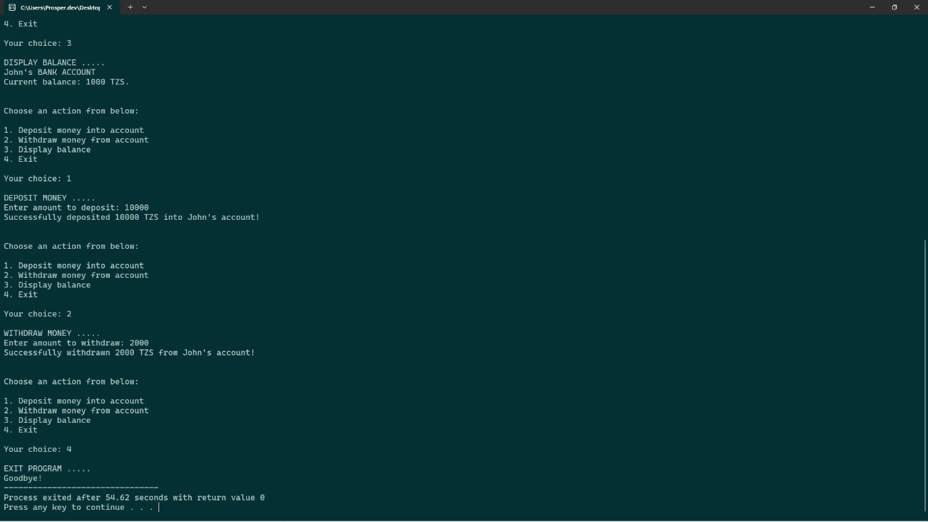
- Second sample run
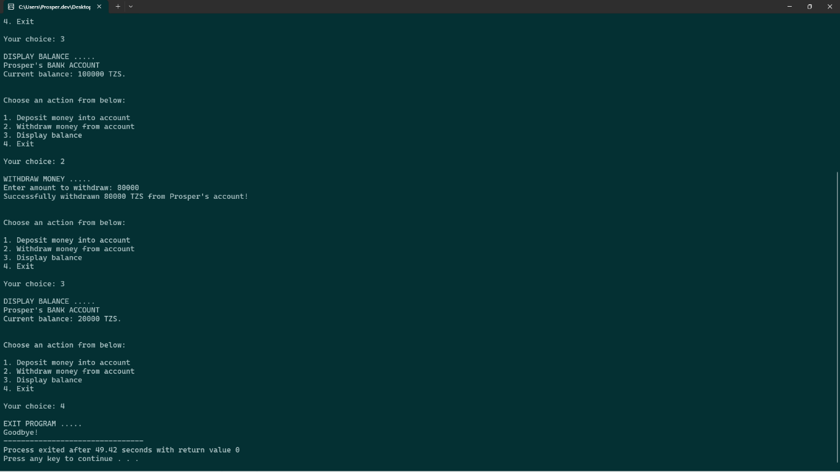
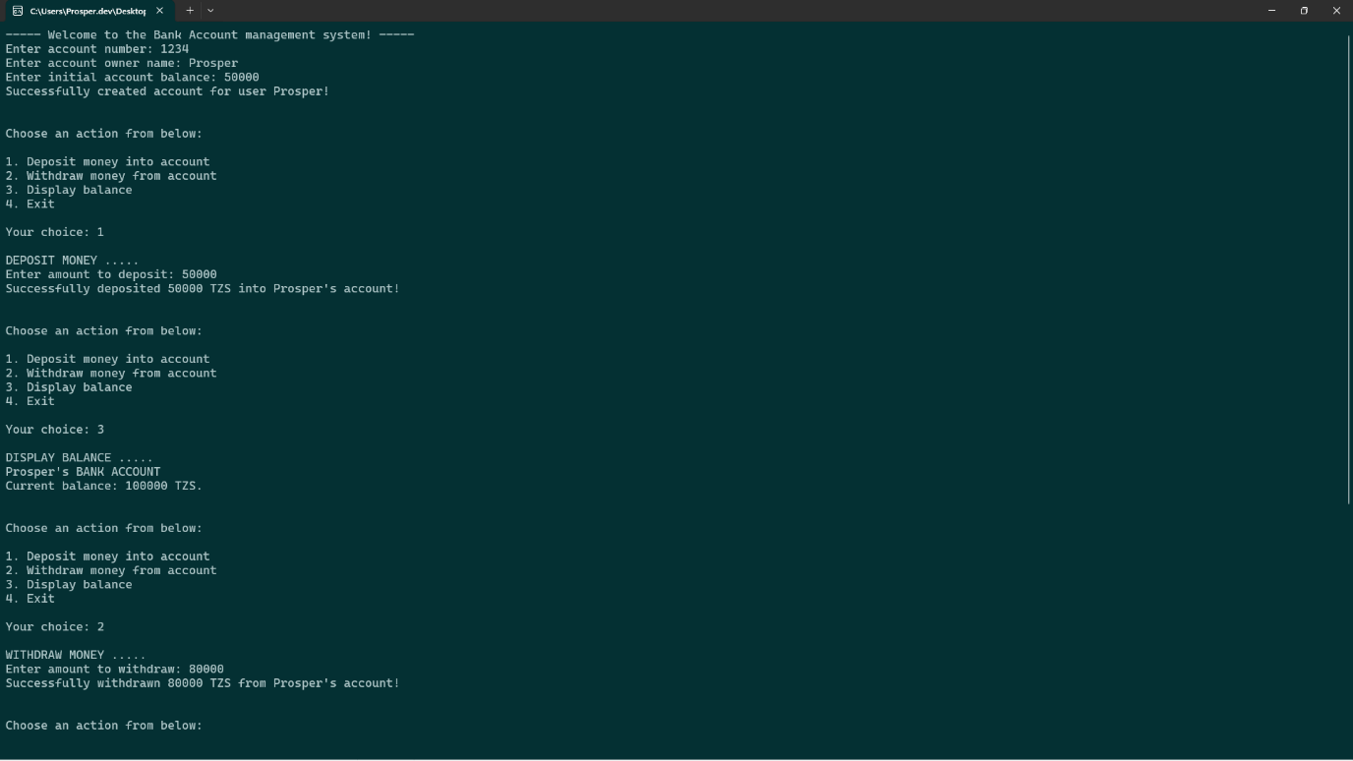

QUESTION 2:
- Source code
""" Student Grading System """
class Student:
'''A class representing an actual student'''
# Create constructor for Student object
def __init__(self, name: str) -> None:
self._name = name
self._marks = [] # a list of the student's marks
self._total = 0
self._grade = ''
self._average = 0
def calculate_average(self) -> float:
'''Calculates student's average mark'''
for m in self._marks: self._total += m
self._average = self._total / len(self._marks)
return self._average
def grade(self) -> str:
'''Grades the student's average mark'''
if 80 <= self._average <= 100: return "A"
elif self._average >= 60: return "B"
elif self._average >= 40: return "C"
else: return "F"
def input_marks(self) -> None:
'''Inputs student marks for five subjects'''
print(f"\nYou are required to input {self._name}'s marks in five subjects....")
iterations = 0
while iterations < 5:
try:
marks = float(input(f"Marks for subject {iterations + 1}: "))
# Validate input for marks
if marks > 100 or marks < 0:
print("[ERROR] Marks must be between 0 - 100! Try again.\n")
continue
# Append valid marks to list and update counter variable
self._marks.append(marks)
iterations += 1
except ValueError:
print(f"[ERROR] Invalid input! Marks must be a number between 0 and 100!Try again.\n")
continue
print(f"Input operation for 5 marks successful! 👍\n")
if __name__ == '__main__':
print("----------📔 WELCOME TO THE STUDENT GRADING SYSTEM 📔---------")
# Prompt user for student name and marks
name = input("\nEnter the student's name: ").strip()
student = Student(name=name)
student.input_marks()
# Compute average score and grade using the student objects methods
average = student.calculate_average()
grade = student.grade()
# Print results
print("\n..... RESULTS FOR STUDENT ..... ")
print(f"Student name: {student._name}")
print(f"Average score: {average:.2f}")
print(f"Grade: {grade}\n")

- First and second test runs


